O‘zbekiston Respublikasi Harbiy xavfsizlik va Mudofaa universitetining Axborot Kommunikatsiya texnologiyalari va Harbiy Aloqa instituti


“Suniy intellekt ” fanidan
4-Mustaqil ish

Topshirdi: kursant Xudoyberdiyev A
Tekshirdi: kapitan Isakov M

8-VARIANT: Ishlab chiqarish (Factory & Production)

Zavod yoki fabrikadagi ishlab chiqarish jarayonlari, brak mahsulotlar va smena tahlili.

1-Savol (NumPy): Sifat nazorati.

Vazifa:

Konveyerdan chiqqan 10 ta mahsulotning og'irligi (grammda): [498, 502, 500, 495, 505, 500, 499, 501, 490, 510].

Normal og'irlik: 500 gr (+/- 3 gr xatolik ruxsat etiladi, ya'ni 497 dan 503 gacha).

1. Massiv yarating.

2. Normadan chetga chiqqan (brak) mahsulotlar sonini aniqlang.

2-Savol (Pandas): Smena hisoboti.

Vazifa:

Ishchilarning ishlab chiqargan mahsulot soni:

Ishchi: Ali, Vali, Hasan, Husan

Smena: Kunduzgi, Kunduzgi, Tungi, Tungi

Mahsulot_Soni: 120, 115, 90, 95

1. DataFrame yaratish.
2. Kunduzgi va Tungi smenalar bo'yicha jami mahsulot sonini hisoblang (groupby).

3-Savol (Matplotlib): Ishlab chiqarish rejasi.

Vazifa:
Haftalik ishlab chiqarish hajmi: [100, 120, 130, 110, 140, 90, 50].
Reja (Nishon): Har kuni 110 ta.
Grafikda kunlik ishlab chiqarishni chiziq (line) bilan, Rejani esa gorizontal qizil chiziq (axhline) bilan tasvirlang.

4-Savol (Seaborn): Mashinalar yuklamasi (Heatmap).

Vazifa:
3 ta dastgoh (M1, M2, M3) ning 3 kunlik (Dushanba, Seshanba, Chorshanba) ish soatlari matritsasi berilgan.
seaborn da Heatmap chizing va har bir katakka raqamlarni yozing (annot=True).
# 1-savol.
import numpy as np
og’irliklari = np.array([498, 502, 500, 495, 505, 500, 499, 501, 490, 510])
min_og’irlik = 497
max_og’irlik = 503
xatolik_mask = (og’irlik < min_og’irlik) | (og’irlik > max_og’irlik)
xatolik_count = np.sum(defective_mask)
print(" Mahsulot og‘irliklari:", og’irlik)
print(" Brak mahsulotlar soni:", defective_count)
print(" Brak mahsulotlar:", og’irliklari[defective_mask])
defective_count--braklar soni.
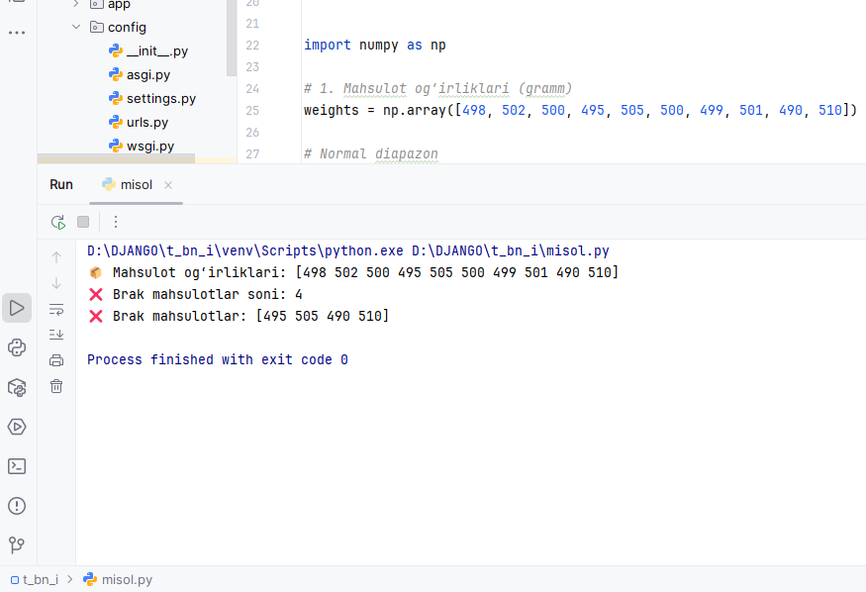
# 2-savol.
import pandas as pd
data = {
"Ishchi": ["Ali", "Vali", "Hasan", "Husan"],
"Smena": ["Kunduzgi", "Kunduzgi", "Tungi", "Tungi"],
"Mahsulot_Soni": [120, 115, 90, 95]
}
df = pd.DataFrame(data)
print("\n Ishchilar jadvali:")
print(df)
shift_summary = df.groupby("Smena", as_index=False)["Mahsulot_Soni"].sum()
print("\n Smena bo‘yicha jami mahsulot:")
print(shift_summary)
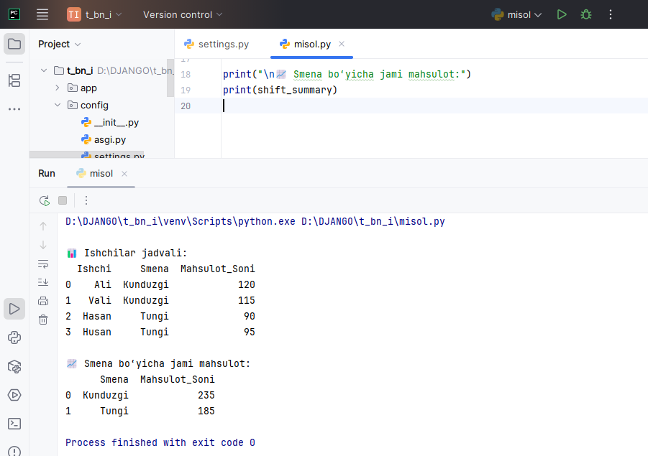

# 3-savol.
import matplotlib.pyplot as plt
production = [100, 120, 130, 110, 140, 90, 50]
days = ["Du", "Se", "Ch", "Pa", "Ju", "Sh", "Ya"]
target = 110
plt.figure(figsize=(10, 5))
plt.plot(days, production, marker="o", linewidth=2, label="Haqiqiy ishlab chiqarish")
plt.axhline(y=target, linestyle="--", label="Reja (110 ta)")
plt.title("Haftalik ishlab chiqarish: Reja va Fakt")
plt.xlabel("Kunlar")
plt.ylabel("Mahsulot soni")
plt.legend()
plt.grid(True)
plt.show()
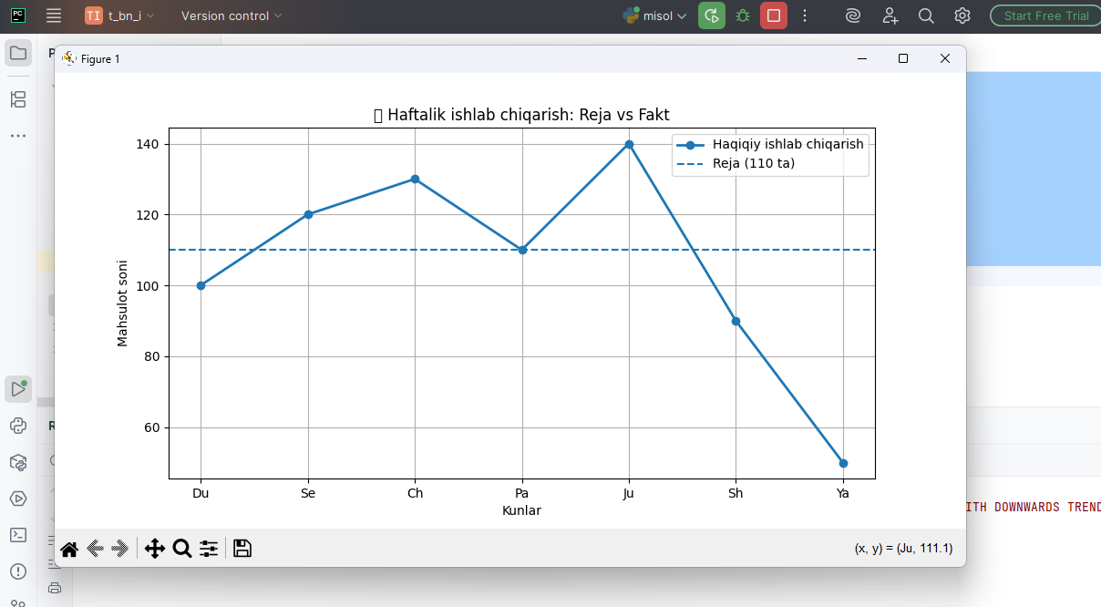
# 4-savol.
import pandas as pd
import seaborn as sns
import matplotlib.pyplot as plt
machine_hours = pd.DataFrame(
data=[
[8, 7, 6],
[6, 8, 7],
[7, 6, 8]
],
index=["M1", "M2", "M3"],
columns=["Dushanba", "Seshanba", "Chorshanba"]
)
plt.figure(figsize=(8, 5))
sns.heatmap(
machine_hours,
annot=True,
fmt="d",
linewidths=0.5
)
plt.title(" Mashinalar yuklamasi (soatlarda)")
plt.ylabel("Mashinalar")
plt.xlabel("Kunlar")
plt.show()
